**GUIDANCE ON PUBLIC PROCUREMENT FOR SMEs AND THIRD SECTOR SUPPLIERS**

As set out in our recently published [Public Procurement Strategy for Scotland,](https://www.gov.scot/publications/public-procurement-strategy-scotland-2023-2028/documents/) the Scottish Government and wider public sector has a long standing commitment to SME engagement, which is embedded in Scottish procurement legislation and sustainable approaches. We continue to inform and test our policies through engagement with private and third sector to ensure they are business friendly. We measure, track and publish the impact of public procurement on outcomes that are good for businesses and employees; good for places and communities; good for society; and are open and connected through our [Ministers' Annual Report on Procurement Activity Across Scotland](https://www.gov.scot/publications/annual-report-procurement-activity-scotland-2021-2022/)[.](https://www.gov.scot/publications/annual-report-procurement-activity-scotland-overview-procurement-activity-2020-21/) And, importantly, we regularly conduct and publish targeted research and surveys to test and seek opportunities to improve our delivery of this key priority.

Our Community Wealth Building (CWB) approach to economic development shows our commitment to strengthen the practical means by which we can achieve our wellbeing economy objectives outlined in the [National Strategy for Economic Transformation (NSET).](https://www.gov.scot/publications/scotlands-national-strategy-economic-transformation/) We are committed to use procurement to help deliver more and better jobs, business growth and shorter supply chains creating greater resilience and supporting net zero ambitions.

We have a comprehensive and joined-up set of policy, tools, systems and guidance which together help simplify our processes and enable buyers and suppliers to access procurement information and opportunities more easily.

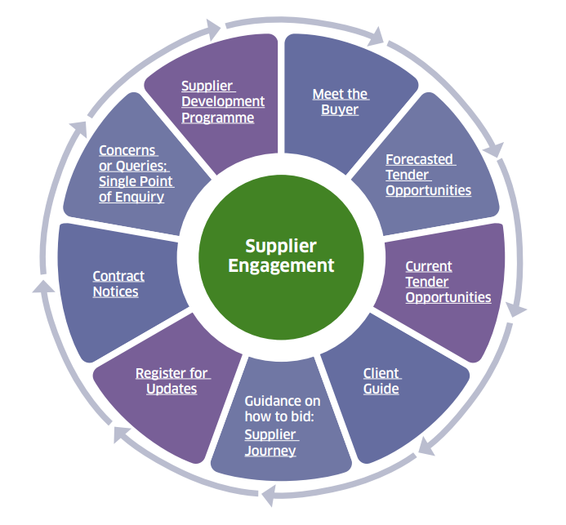

**This document seeks to clarify the sources of support which we have put in place to help SMEs and Third sector engage with the public sector and to better enable them to bid for and win public contracts.**

# FINDING OPPORTUNITIES

[Public Contract Scotland](https://www.publiccontractsscotland.gov.uk/Default.aspx) (PCS):

* An advertising portal for all regulated public sector contracts across Scotland, where suppliers can receive alerts on the types of opportunities for which they have registered an interest.
* Suppliers can complete a [Supplier Finder Profile](https://www.publiccontractsscotland.gov.uk/helpandresources/download/1fe41a53-e38c-4bb8-9676-f55ccb82ce06) allowing them to build on the information in their company profile, providing buyers with detailed information regarding the goods, services or works which they can provide to the Public Sector, and enabling buyers to identify them as a potential bidder for relevant [Quick Quotes.](https://www.publiccontractsscotland.gov.uk/helpandresources/download/8efa186d-6157-4801-bbe0-71142a21d009)
* PCS also includes [current](https://www.publiccontractsscotland.gov.uk/Search/Search_MainPage.aspx) tender opportunities, including Quick Quotes for lower value contract and innovation opportunities which are often of most interest to SMEs. These also provide lead buyer contact information.
* PCS includes search functionality for contract award notices on goods, services and works for an organisation, allowing suppliers to see who the public sector are currently contracted with, helping them assess and seek opportunities in the supply chain as a sub-contractor. If you are interested in national, sector or local public sector contracts, businesses can also review contract registers on relevant organisations’ procurement websites, for example [Scottish Government Collaborative Contracts.](https://www.gov.scot/publications/frameworks-and-contracts/)
* [User manuals and videos](https://www.publiccontractsscotland.gov.uk/helpandresources/userguides) are available on creating PCS accounts, setting up alerts, Frequently Asked Questions (FAQs) and much more.
* PCS is used to send out *‘e-blast’* updates and useful information for suppliers interested in public sector contracts. This can be useful in understanding updates to public procurement policy, tools, events and other information of interest.

# BIDDING SUCCESSFULLY

[Supplier Journey](https://www.supplierjourney.scot/)

* This on-line guidance is regularly updated and has been developed specifically to support suppliers, making it easier for them to bid for public goods and services, including:

o How do I bid - registering, bid process, hints and tips and FAQs:

* <https://www.supplierjourney.scot/support-available>
* <https://www.supplierjourney.scot/i-want-bid-what-do-i-do>
* <https://www.supplierjourney.scot/faqs>

o Decision, award of contracts and much more

[Client Guide to Construction Projects:](https://www.gov.scot/collections/client-guide-to-construction-projects/)

* This can assist in developing potential suppliers’ understanding of how the public sector delivers construction projects.
* The [Construction Pipeline Forecast Tool](https://pipeline.scottishfuturestrust.org.uk/) provides a look forward as to the anticipated public sector spend within construction. The forecast tool has been developed by the Scottish Futures Trust in partnership with industry and public sector bodies.

[Supplier Development Programme](https://www.sdpscotland.co.uk/) (SDP):

* Working with all 32 Scottish local authorities, Scottish Government and over 18 other government agencies, this Programme is a one-stop-shop to help Scottish SMEs (particularly micros) and third sector organisations with little or no experience of tendering (and often too small to have dedicated bid/tender resources) learn how to and to improve their bidding capability when competing for public sector contracts.
* SDP helps businesses and social enterprises to become “tender ready” by delivering a programme of free tender training, webinars, events and online via their e-learning portal, all of which can be accessed via their [website.](https://www.sdpscotland.co.uk/) SDP also raise awareness of up-and-coming contracts, often delivering aligned tender training to support those who wish to bid for the contract.

[Single Point of Enquiry](https://www.gov.scot/publications/single-point-of-enquiry/) (SPOE)

* Where bidders – or suppliers in the supply chain - perceive a breach of policy and have been unable to resolve issues directly with the main contractor or public contracting authority, the SPoE service offers independent advice to suppliers with concerns about a specific tender exercise.

# ENGAGING WITH THE PUBLIC SECTOR

* [Meet the Buyer:](https://www.sdpscotland.co.uk/events-mtb-prepare/) The [SDP,](https://www.sdpscotland.co.uk/) in collaboration with the Scottish public sector, run a series of events across Scotland. These are an opportunity for suppliers to introduce themselves to public sector buyers and private sector primary contractors to learn about new projects, contracts, framework opportunities and supply chain opportunities.

* [Procurex Scotland](https://www.procurexscotland.co.uk/) connects buyers and suppliers from across Scotland’s public sector, featuring extensive skills development, networking, collaboration and product showcase opportunities.

* [P4H Scotland](https://www.p4hscotland.co.uk/) - the Procurement Event for Health, connects buyers and suppliers across the healthcare supply chain, and features extensive skills development, networking, collaboration and product showcase opportunities.

* The Scottish Government regularly conduct [supplier surveys](https://www.gov.scot/publications/public-procurement-survey-suppliers-2020/documents/) or targeted research to gather suppliers views and experiences of the bidding process and of delivering public sector contracts, to inform future thinking on the delivery of public procurement in Scotland.

* In addition, we facilitate targeted supplier, SME and Third Sector engagement to inform policy and practice approaches, and we encourage engagement between procurement and Scottish, Regional and Local Enterprise organisations to better understand and take advantage of supply chain opportunities.

# Innovation Portal

• The [Scotland Innovates](https://innovator.scot/about) service provides a [landing zone](https://innovator.scot/) for an easy to use, secure route to connect with the Scottish public sector, providing potential suppliers with information, guidance and support on how to develop ideas and innovations into goods, services, works and technologies that may be of use in the provision of public services in Scotland.

# FAQs AND CASE STUDIES

[Supplier FAQs](https://www.supplierjourney.scot/faqs)

[Talking “sustainable change” and supplying the public sector with Hey Girls](https://blogs.gov.scot/public-procurement/2021/11/30/talking-sustainable-change-and-supplying-the-public-sector-with-hey-girls/)

[“Spreading our wings” – Rural SME showcase with Lewis Builders](https://blogs.gov.scot/public-procurement/2022/11/29/spreading-our-wings-rural-sme-showcase-with-lewis-builders/)

[“Waste not, want not” – Rural SME showcase with Levenseat](https://blogs.gov.scot/public-procurement/2022/10/20/waste-not-want-not-rural-sme-showcase-with-levenseat/)

[Experiences of micro and women-led businesses appointed to the Marketing Services Framework](https://blogs.gov.scot/public-procurement/2023/06/27/sme-day-2023)

[Supplier Development Programme Case Studies](https://www.sdpscotland.co.uk/media-case-studies/)